

Hi,

Thank You for showing interest to work with [www.hospet.online](http://www.hospet.online)

You have been shortlisted by our moderators.

You will receive Rs. 7000 /Month for 2 successive months if you are selected. We may consider hiring you if we like your work.

**PLEASE READ ALL INSTRUCTIONS CAREFULLY BEFORE REPLYING**

Before we begin your internship as a content writer, we would like to conduct a small test to get the idea of your writing skills.

You have to complete the assignment within 48 hours of receiving this email.

* You may not apply to this internship if you have previously applied for the same.

**Assignment** 1a

Do a google search for the keyword “Hospet online”, note down the position of hospet.online website on the search result page after you have clicked and verified the site URL exactly. (On desktop and mobile)

*In the below example the position of hospet.online website is 1st.*

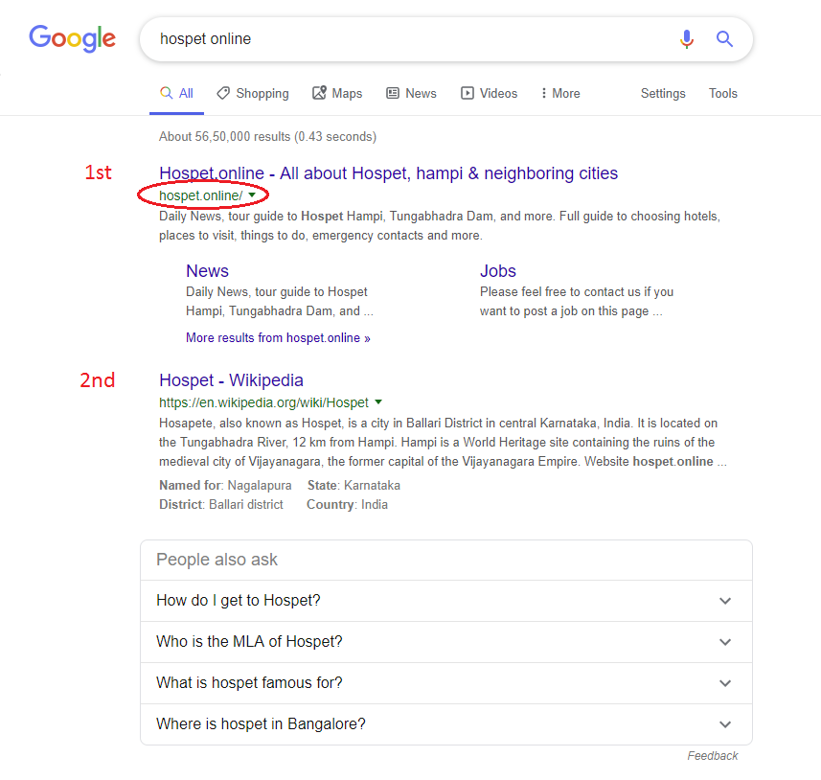

**Answer to assignment 1a**

**The position on hospet.online for the keyword “hospet online” on desktop version is**

Your answer

|  |
| --- |
| First |

**The position on hospet.online for the keyword “hospet online” on mobile version is**

Your answer

|  |
| --- |
| First |

**Assignment** 1b

Similar to assignment 1a, do a google search **(on a new tab)** for the keyword “Hospet”, note down the position of hospet.online website on the search result page after you have clicked and verified the site URL exactly. (Search up to 7 pages until you find the URL) (On desktop and mobile)

**Answer to assignment 1b**

**The position on hospet.online for the keyword “hospet” on desktop version is**

Your answer

|  |
| --- |
| Two |

**The position on hospet.online for the keyword “hospet” on mobile version is**

Your answer

|  |
| --- |
| Third |

2

Browse through all the pages of hospet.online and tell us what do you think. What did you like the most about the website? Is there something that you didn’t like? How can you help hospet.online?

Your answer

*300 words minimum*

|  |
| --- |
| Hospet. Online is a platform where any user got information about the recent news, |
| Details about tourism and jobs as well. In addition you get a complete information |
| About the hotels as well. Somehow you would get complete information for any |
| Query to you ask from this platform. |
| In addition to that if any want ads for their website to hostpet would also deals with |
| that services. You can buy or sale ads through this platform. So what I would a |
| Complete platform where you would get different stuff on a single platform. |
|  |
| As per the question that why like the most important is the category of Jobs where |
| User got job opportunity and know about the different job details as well. |
| The another thing that I like the most is about the news feed option that would get |
| Relevant information about the day to day activities. |
|  |
| So as per the question that what I don’t Like about so about that I don’t think so there is anything in hospet online platform. But what I think that there should |
| be add on category like you mentioned about the events you conduct. So you can |
| Share this information in an interesting way. So that more and more people would |
| Join from this platform as well. |
|  |
| As per help is concerned as I am applied for SEO, so I can help in ranking this website |
| On each and every keyword. As mentioned above the hospet online is rank on First |
| Position. Similar to that one I would help in ranking to first position on other keyword. |
| Apart from that if the work of content writing is giving to me. So I can really help |
| Hospet in that one also. Because the reason is that I have a 6 months experience in this |
| Field. So this is what I want to say about it. |
|  |
|  |
|  |
|  |
|  |
|  |
|  |
|  |
|  |
|  |
|  |
|  |
|  |

3

Write an article on any 1 of the topics mentioned below.

1. Tips to travel cheaper
2. How to choose a perfect hotel
3. Travel check list

* Only original content is considered.
* No using general Wikipedia info.
* You may not copy articles from internet (you can refer)
* You may not write or copy an article which is already existing on www.hospet.online website.
* You may review other articles related to your selected topic and write your own opinion.
* The article should be at least 600 words.
* No short language.

Your answer

*600 words minimum*

|  |
| --- |
| How To Choose A Perfect Hotel |
| As a human being whenever we plan for visiting some places on the occasion of |
| summer or winter holidays. So the first thing is to be get into our mind is the perfect |
| Hotel for giving rest to our body and also for the food purpose as well. So it is really |
| Important aspect that whenever someone have to make a decision for choosing a |
| Perfect hotel then given below are some key points to be remember while booking |
| Any hotel. |
| 1 Choose a hotel by location |
| 2 Checkout the reviews |
| 3 Check and compare the prices as well |
| 4 Check the safety measures |
| 5 Experiences Provided |
| So now we will be discussing in detail about these certain points that we have to be |
| Kept into our mind that are as follows. |
| 1 **Choose a hotel by location** :- One of the most important point is that on choosing |
| a hotel according to the location. It states that your hotel would be matched by your |
| Location. As you would definitely want that the features you want into the location is |
| Also equally matched with your hotel |
| So as you would be really feel happy and joy in that hotel with your family members |
| And from friends as well. Somehow the place you visit outside should also have a |
| equal balanced with your hotel. Those fresh happiness that your get from outside the |
| hotel would also feel the same inside the well. Then you can say that you have invest |
| your money into a right place. |
| 2 **Checkout the reviews** :- It is also really important thing to be do, while booking |
| hotel is to first checkout the reviews of that hotel. As from there onwards you would |
| Definitely get a clear picture in your mind towards booking that hotel. |
| Those reviews would really helpful in deciding whether that hotel would be good for |
| or not. From there onwards you can easily set your decision. As that hotel would |
| satisfy your requirements or not. |
| 3 **Check and Compare price as well** :- This is also one of the important point to be |
| Kept in mind will booking any hotel. It is really important for you to check and |
| Compare the price of various hotel on the basis of your requirements. |
| As you can easily compare the various hotel just by scale up or down the price level |
| According to your pocket money and the features you want or not. So that thing is |
| to be really kept into mind. |
| 4 **Check the safety measures** :- As safety is also one of key picks to be remember into |
| your mind will booking any hotel or choose any hotel. Before choosing any hotel you |
| have to be kept in mind about the lobby and rooms to be secure. |
| Generally we measures or think on other aspects while choosing any hotel. But it is |
| Important that we also have to be keep an eye on that point also. Because it is our |
| First and foremost priority. |
| 5 **Experiences Provided** :- It is also one of the most important point while choosing |
| your [perfect hotel](https://hospet.online/). As experience n life would never be fail. That is also associated |
| at the time of ***choosing you perfect hotel*** for your holidays |
| With that you have to be kept in minds the features that hotel is providing to you. |
| As now a days more and more new hotels are available in the market. But it is up to |
| you on what basis you choose your hotel. But IN my point of view you would |
| definitely go for experienced hotel. As this is one of reason why the hotel would |
| Sustain in the market from many years. |
|  |
| So that is all from my side regarding the key points you have to consider while |
| **choosing your perfect hotel**. So I hope you would definitely like this information and |
| If yes so don’t forget to share this information with your friends. |
|  |
|  |
|  |
|  |
|  |
|  |
|  |

Any additional files like image or video can be attached along with the email.

You may reply to us directly or get in touch through the details below.

Email: [intern@hospet.online](mailto:intern@hospet.online)

We wish you all the best.